Morocco

## Population Data

The data set shows the political stability estimate of the country each year.

## # A tibble: 23 x 5  
## country iso3c date population popCategory5  
## <chr> <chr> <dbl> <dbl> <chr>   
## 1 Morocco MAR 1996 27383473 medium   
## 2 Morocco MAR 1997 27754571 medium   
## 3 Morocco MAR 1998 28110443 medium   
## 4 Morocco MAR 1999 28455509 medium   
## 5 Morocco MAR 2000 28793679 medium   
## 6 Morocco MAR 2001 29126330 medium   
## 7 Morocco MAR 2002 29454768 medium   
## 8 Morocco MAR 2003 29782884 medium   
## 9 Morocco MAR 2004 30115214 medium   
## 10 Morocco MAR 2005 30455561 medium   
## 11 Morocco MAR 2006 30804683 medium   
## 12 Morocco MAR 2007 31163673 medium   
## 13 Morocco MAR 2008 31536811 medium   
## 14 Morocco MAR 2009 31929087 medium   
## 15 Morocco MAR 2010 32343389 medium   
## 16 Morocco MAR 2011 32781850 medium   
## 17 Morocco MAR 2012 33241898 medium   
## 18 Morocco MAR 2013 33715693 medium   
## 19 Morocco MAR 2014 34192347 medium   
## 20 Morocco MAR 2015 34663603 medium   
## 21 Morocco MAR 2016 35126296 medium   
## 22 Morocco MAR 2017 35581294 medium   
## 23 Morocco MAR 2018 36029138 medium

# Population growth data

## # A tibble: 23 x 5  
## country iso3c date popGrowth popGrowthCat5   
## <chr> <chr> <dbl> <dbl> <chr>   
## 1 Morocco MAR 1996 1.43 slow growth rate  
## 2 Morocco MAR 1997 1.35 slow growth rate  
## 3 Morocco MAR 1998 1.27 slow growth rate  
## 4 Morocco MAR 1999 1.22 slow growth rate  
## 5 Morocco MAR 2000 1.18 slow growth rate  
## 6 Morocco MAR 2001 1.15 slow growth rate  
## 7 Morocco MAR 2002 1.12 slow growth rate  
## 8 Morocco MAR 2003 1.11 slow growth rate  
## 9 Morocco MAR 2004 1.11 slow growth rate  
## 10 Morocco MAR 2005 1.12 slow growth rate  
## 11 Morocco MAR 2006 1.14 slow growth rate  
## 12 Morocco MAR 2007 1.16 slow growth rate  
## 13 Morocco MAR 2008 1.19 slow growth rate  
## 14 Morocco MAR 2009 1.24 slow growth rate  
## 15 Morocco MAR 2010 1.29 slow growth rate  
## 16 Morocco MAR 2011 1.35 slow growth rate  
## 17 Morocco MAR 2012 1.39 slow growth rate  
## 18 Morocco MAR 2013 1.42 slow growth rate  
## 19 Morocco MAR 2014 1.40 slow growth rate  
## 20 Morocco MAR 2015 1.37 slow growth rate  
## 21 Morocco MAR 2016 1.33 slow growth rate  
## 22 Morocco MAR 2017 1.29 slow growth rate  
## 23 Morocco MAR 2018 1.25 slow growth rate

## Population trend

The plot shows the population trend of the country.

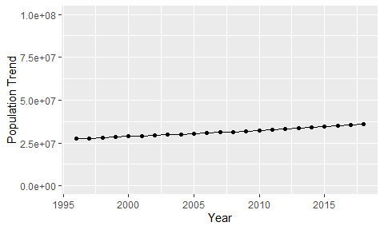

Political Stability Trend

# Population growth trend

The plot shows the population growth rate trend of the country.

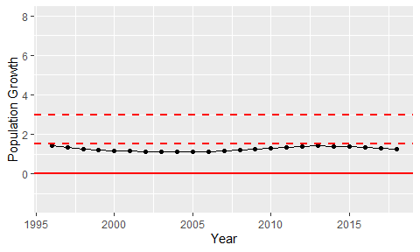

Population Growth Trend